

OWNER’S MANUAL

HELLO,
Thank you for purchasing an inﬂatable stand up paddle board and ...

WELCOME TO THE REBEL BOARDS FAMILY!

We are a small team of outdoor adventurers who strive to make paddle boarding as enjoyable and fulﬁlling as it is affordable and accessible for you.

Having any issues, or missing any part of your board?
Please contact us immediately so we can help you:
info@rebel.mk, or call us on +389 75 266316.

WHAT’S INCLUDED IN YOUR BOX

• YOUR PADDLE BOARD ROLLED UP
• RUCKSACK BACKPACK
• ADJUSTABLE ALUMINUM PADDLE
• DOUBLE ACTION HAND PUMP
• 1 REMOVABLE CENTER FIN
• 2 REMOVABLE SIDE FINS
• LEASH
• REPAIR KIT (VALVE WRENCH, PATCHES, GLUE).

BUT... YOU SHOULD TO KNOW THAT:

Nothing is missing, we double-checked everything :-)
Before we handed your board, it passed through OUR OWN INSPECTION procedure:
1. Inflated to 15psi and observed it for 3 days for possible air-pressure drop.
2. Visually checked the nose and tail of the board for asymmetrical bendings or deformations.
3. Checked the air-valve with soap and water, for possible air leaks.
4. Visually checked the air-valve, d-rings and fin-slide for asymmetrical (off-center) peeling alignments.
5. Visually checked the whole SUP area for possible unpeelings.

HAPPY PADDLING :-)
WE CONFIRM THAT EVERYTHING IS OK WITH YOUR BOARD.

SAFETY WARNINGS!

Failure to follow these warnings and precautions below may lead to serious injury or death!

MAXIMUM NUMBER OF PEOPLE:
For ARROW, MAGIC, EXOTIC, SONIC and SONIC X - 1 person at a time. It's dangerous to have more people on this SUP at a time.
For PRIME - 2 person at a time with total weight 160 kg.

DO NOT EXCEED YOUR PHYSICAL ABILITY: Determine how long you are able to paddle or swim before using your paddle board.

ALWAYS PADDLE WITH OTHERS: Avoid Paddling alone.

ALWAYS WEAR A LEASH: Prevents you from becoming separated from your board in case you fall.

FAMILIARIZE YOURSELF WITH THE BODY OF WATER WHERE YOU PLAN ON USING YOUR PADDLE BOARD: Check for any known hazardous areas, hours of operation, and where the nearest help can be reached in case of emergency.

DON’T USE YOUR PADDLE BOARD IN SEVERE WEATHER OR IN STRONG WINDY CONDITIONS.

SLIP HAZARD: Hull materials may become slippery when wet. Always wear slip resistant footwear.

HYPOTHERMIA CAN CAUSE DEATH: It can occur even in relatively warm water. Survival time decreases dramatically as water temperature drops. Wear a wetsuit when necessary.

ALWAYS WEAR A LIFE JACKET OR OTHER FLOTATION DEVICE.

NEVER USE THIS PADDLE BOARD AFTER SUNSET: Always carry a waterproof ﬂash light in case you are caught in the water after dark to warn other boaters of your presence.

INFORM OTHERS OF YOUR PADDLING PLANS: Where you plan to go and how long you plan to be gone.

KIDS MUST BE SUPERVISED AT ALL TIMES.

DO NOT CONSUME ALCOHOL OR DRUGS THAT MAY AFFECT YOUR ABILITY TO SAFELY OPERATE THIS PADDLE BOARD.

AVOID RIDING YOUR BOARD THROUGH SHALLOW WATER: Fins may strike submerged objects causing damage to the ﬁns and/or ﬁn boxes which is not covered by warranty.

DO NOT LEAVE YOUR PADDLE FLOATING ON THE WATER MORE THAN 10 MINUTES: It can sink, because consumes the water slowly.

DO NOT PADDLE IN MODERATE OR HIGH WAVES: Falling in water can lead to serious injuries and damaging your board.

WHEN DEFLATING YOUR BOARD - KEEP YOUR FACE AWAY FROM THE VALVE as the air will escape rapidly and could cause harm.

INSTALLATION INSTRUCTIONS

1. PREPARING THE BOARD:
Find a clean flat surface free of any debris or sharp objects and unroll your paddle board with the deck and valve facing up.

2. PREPARING THE VALVE:
Remove the valve cover. Make sure the valve is locked to keep air from escaping (up position). If the valve stem is down and air is escaping, just push down the valve stem.

3. INFLATING THE BOARD:
Push the pump hose into the air valve and twist clock-wise until you feel it lock onto the valve.
Begin pumping air into the board. Note that the pressure gauge will not register pressure in the first 7-8 minutes. Once the board reaches the desired pressure (15psi), remove the hose from the valve and replace the valve cap onto the valve body. DO NOT over-inflate the board. RECOMMENDED PRESSURE 12-15PSI. Check pressure before each use. Do not transport fully pressurized. TRAVELING FROM LOW TO HIGH ALTITUDES WILL INCREASE AIR PRESSURE IN THE CHAMBER AND POSSIBLY DAMAGE YOUR BOARD DUE TO OVER-PRESSURIZATION.

4. DO NOT EXCEED THE RECOMMENDED PRESSURE!
DO NOT USE AN UNREGULATED AIR COMPRESSOR TO FILL THE BOARD. EXCEEDING THE RECOMMENDED PRESSURE WILL PERMANENTLY DAMAGE THE BOARD AND VOIDS THE WARRANTY.

5. IF THE VALVE LEAKS:
Use the supplied crown wrench to tighten the valve clock-wise and stop the leak.

FIN INSTALLATION

1. Slide the central ﬁn into the center mounting slot and lock in place by
inserting the locking pins into the base.
2. Slide the two smaller outer ﬁns into the slots on the outside of the hull
and lock in place by inserting the locking pins into the base.
3. Some force may be necessary to fully insert the ﬁns into their slots.

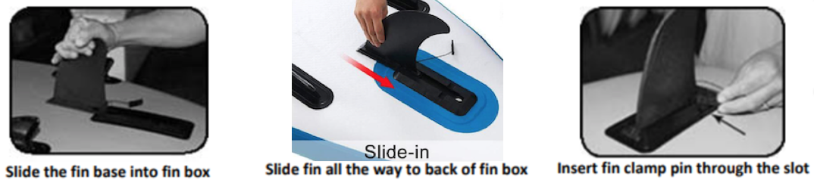

DEFLATION, STORAGE and CARE

1. FIN REMOVAL:

Lay board with ﬁns facing up on a clean surface free of debris and sharp objects. Remove the central and side ﬁns by removing the locking pin and sliding them out of their mounts.

2. CLEAN AND DRY THE BOARD:

If used in sea water, with the board inﬂated and the valve closed, rinse the board with fresh water to clean it of any sand, salt, and debris. Do not use harsh chemicals for cleaning. Allow the board to dry completely. Do not store the board while still wet to prevent mildew build up.

3. DEFLATING THE BOARD:

Push down the valve stem. Keep your face away from the valve as the air will escape rapidly and could cause harm.

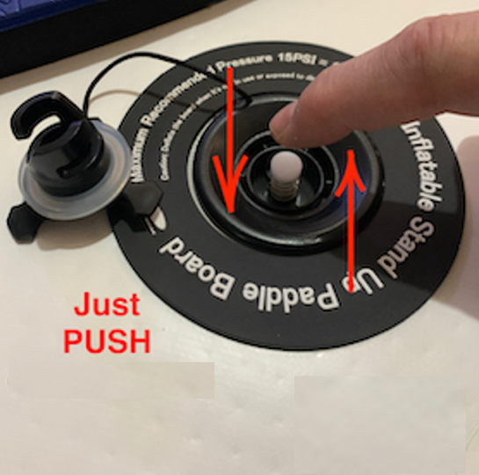

4. ROLLING UP THE BOARD:

a. With the board deﬂated and the valve still open, start at the nose of the board opposite the valve. Roll the board as tight as you can until reaching the valve.

b. Close the valve stem by pushing down to the up/closed position and place the valve cap.

c. Pack your board in it’s backpack and store it in a clean and dry place.

5. PROTECT FROM HEAT AND COLD WATER

DO NOT pump to a high pressure and let the board sit out in the hot sun. If the board is going to be in a warm environment, slightly deflate the board and allow the heat from the sun to increase the internal pressure. If you must store the board temporarily in the sun, protect your board by covering with a towel or storing in shaded area. When paddling, the colder temperature of the water may cause a slight loss in the pressure. If going for a long ride it is a good idea to carry a pump with you so that you can add some air if necessary.

LEAK DETECTION AND REPAIR

Your new inflatable stand-up paddleboard is made of a highly durable PVC. If a tear or a puncture occurs, the PVC is very easy to repair. Repairs are done easily with the provided repair kit. Read the following instructions for leak detection and repair tips:

If the board is losing air pressure, and it is not caused by colder temperatures, check the board for leaks, starting with the valve. A leaking valve is rare, but if you do find a leak, we can send you a replacement valve. To locate a leak, we recommend mixing soap and water in a spray bottle and spray it around the valve. If you see bubbles forming, check the valve seating and base and make sure the valve insert is screwed in tight. If you continue to have problems, it’s probably time to order a new valve. The whole valve can be replaced using a simple tool that comes with the replacement valve.

If the board is losing air and there is no problem with the valve, there is probably a small puncture or unpeeled part. They can be repaired easily and permanently. Spray around the board until air bubbles become visible and mark the position of the leak. If you do not find air bubbles, inflate the board to maximum air pressure and try to listen to find the leak. If you can narrow the area down, return with a spray bottle to identify the source of the leak.

Your board comes with a repair kit as a standard accessory. Cut a piece of repair material large enough to overlap the damaged area by approximately 1.5 cm. Make the edges round. Apply glue to the underside of the patch and around the area to be repaired. Too much glue will interfere with a proper repair. Allow adhesive to become tacky by letting it dry for 3-4 minutes and then carefully apply the patch to the repair area with a very firm pressure, starting at one corner and working outwards. Rub the entire patch area and the edges of the patch. Allow the patch to dry for at least 12 hours before inflating the board.

2 YEARS WARRANTY

We warrant this product for a period of 2 (TWO) YEARS from the date of purchase.

We will make the ﬁnal warranty determination, which may require inspection and/or photos of the equipment, which clearly show the defects.

If a product is confirmed to be defective, the warranty covers the repair or replacement of the defective product only.

This warranty does not cover damage caused by misuse, abuse and improper using like:

- Towing your board with a motor-powered boat,
- Paddling on high waves,
- Paddling in shallow water (breaking the fin or scratching the bottom of the board),
- Paddling in fast rivers,
- Over-inflating your board above 15 psi,
- Damage or defects caused by impact with other boards, rocks, sharp objects, docks, etc.
- Exceeding the maximum weight of your board,
- Overheating and direct sun exposure,
- Improper storage,
- Not following the safety warnings.

SPECIFICATIONS

ARROW 11’0: Fusion tech. with 3 layers side rails. 335 x 81 x 15 cm, 10 kg. For riders up to 100 kg.

MAGIC 11’6: Fusion tech. with 3 layers side rails. 350 x 81 x 15 cm, 11 kg. For riders up to 120 kg.

PRIME 12’0 (2022): Fusion tech. 365 x 84 x 15 cm, 11,3 kg. For 1-2 riders up to 160 kg.

NEW PRIME 12’0: Fusion tech. with 3 layers side rails. 365 x 84 x 15 cm, 11,3 kg.
For 1-2 riders up to 160 kg.

EXOTIC 12’6: Fusion tech. with 3 layers side rails. 381 x 75 x 15 cm, 11.2 kg.
For riders up to 110 kg.

SONIC 12’6 (2022): Fusion tech. 381 x 75 x 15 cm, 11 kg. For riders up to 110 kg.

SONIC X 12’6: Fusion tech. with X-woven drop-stitch and carbon (3rd layers) side rails.
381 x 78 x 15 cm, 9.5 kg. For riders up to 120 kg.

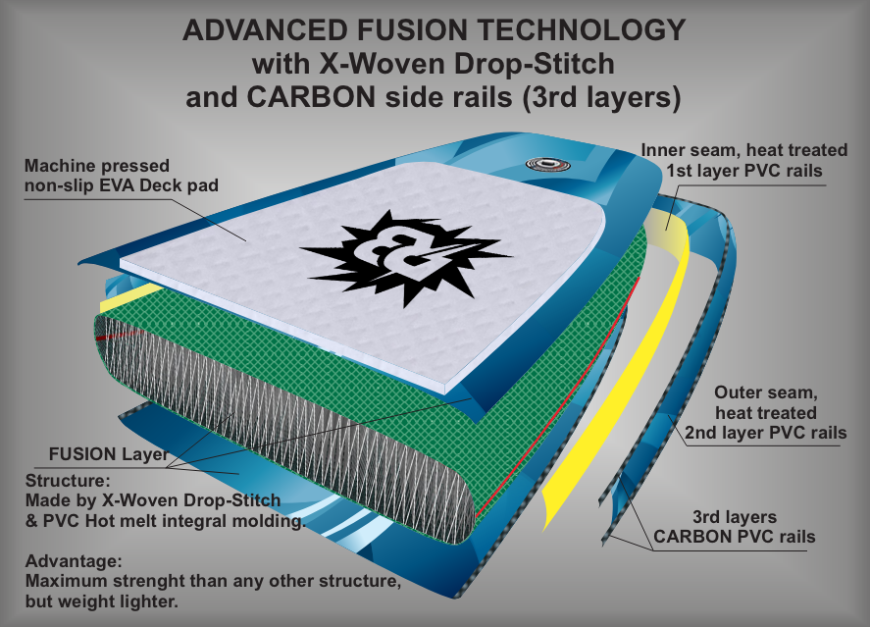
SONIC X 12’6

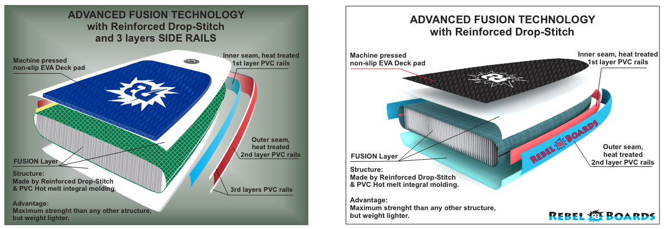
ARROW 11’0, MAGIC 11’6, NEW PRIME 12’0, EXOTIC 12’6 PRIME 12’0 (2022), SONIC 12’6 (2022)

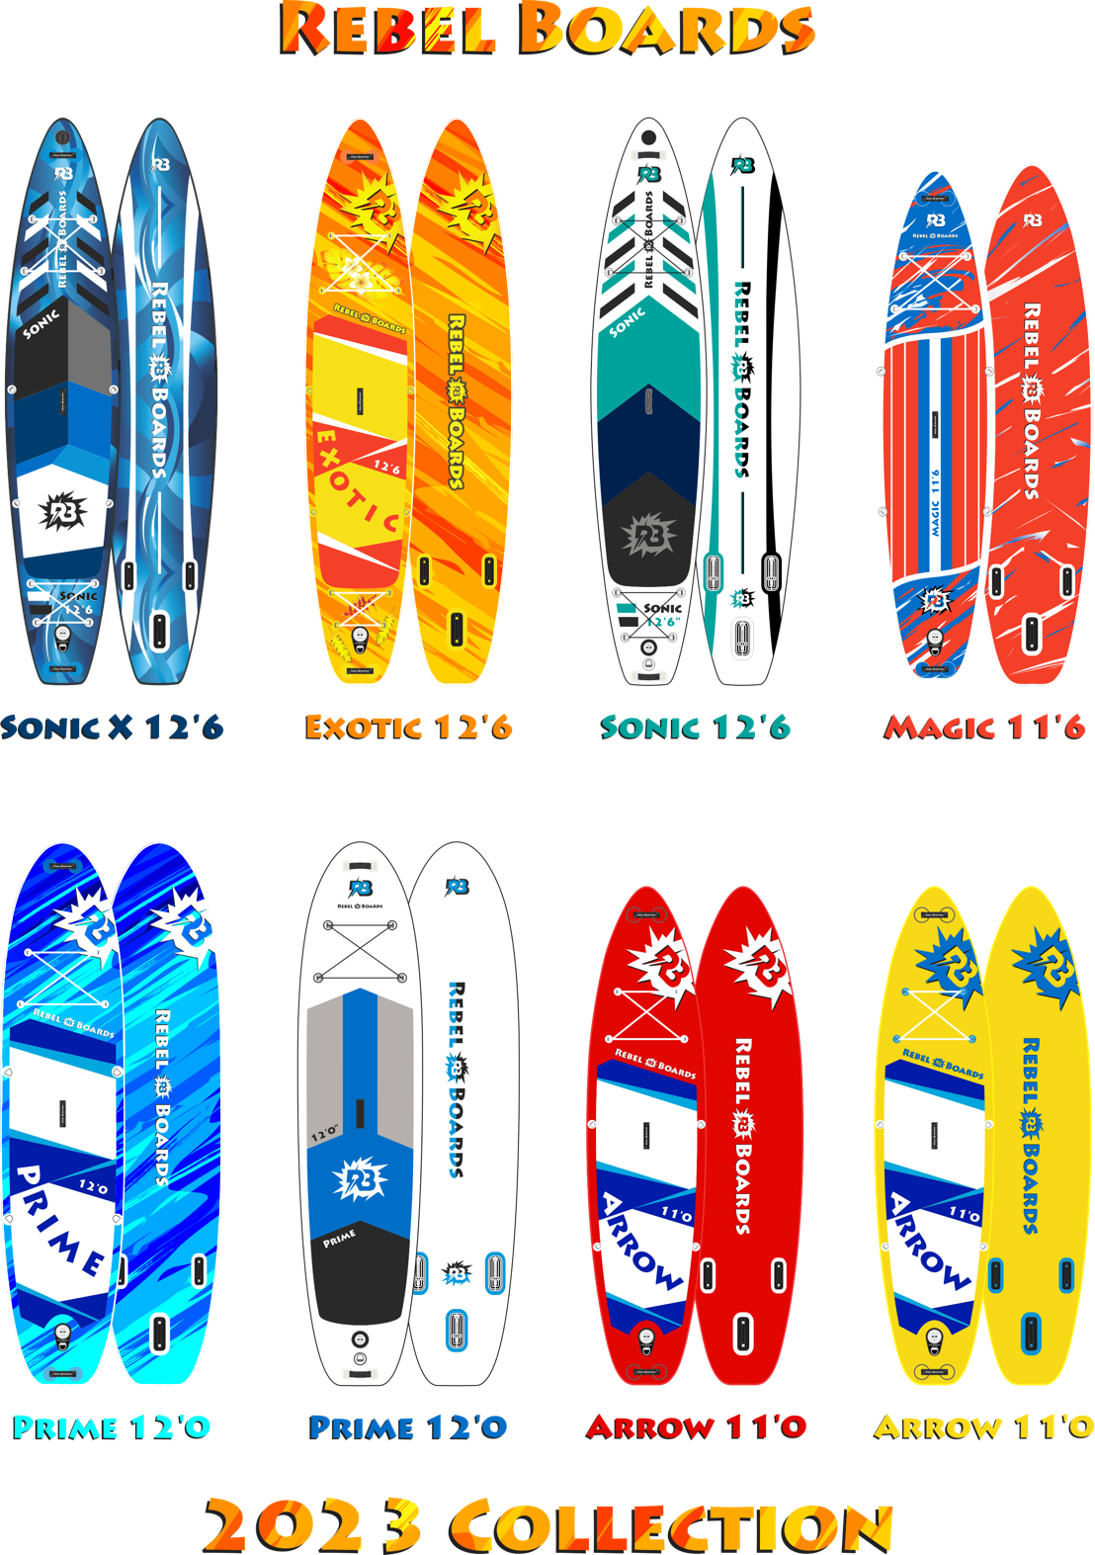

WARRANTY LIST

Importer and official service: REBEL BOARDS DOOEL SKOPJE
Address: 9-Maj, 36-12, Skopje, Macedonia
Phone: +389 75 266316

Product: Rebel Boards SUP - Inflatable paddleboard

SUP name: Prime 12'0" Serial number: FWR400

Date of purchase: ________________

Statement:
Service and maintenance, repairs and supply of spare parts are provided within the warranty period for at least five years from the day of production of the product, but not less than two years from the date of expiration of the product warranty. Defects that will be identified, will be removed free of charge within 30 days from the moment of delivery of the SUP in our service.

The consumer has the legal rights arising from the national legislation governing the sale of the products and these rights are not endangered by the guarantee. In order to get his rights, the consumer is obliged to show this warranty list.

Terms and conditions:
We warrant this product for a period of 2 (TWO) YEARS from the date of purchase.

We will make the ﬁnal warranty determination, which may require inspection and/or photos of the equipment, which clearly show the defects.

If a product is confirmed to be defective, the warranty covers the repair or replacement of the defective product only.

This warranty does not cover damage caused by misuse, abuse and improper using like:

- Towing your board with a motor-powered boat,
- Paddling on high waves,
- Paddling in shallow water (breaking the fin or scratching the bottom of the board),
- Paddling in fast rivers,
- Over-inflating your board above 15 psi,
- Damage or defects caused by impact with other boards, rocks, sharp objects, docks, etc.
- Exceeding the maximum weight of your board,
- Overheating and direct sun exposure,
- Improper storage,
- Not following the safety warnings.

______________________________________
Authorized signatory (signature and seal)

